Predicting the Social Media Usage and Emotional Well-Being Using Machine Learning

Izman Adam – 23041489 , Abul Faiz - 23026170 , Mohamed Nahil - 23041479

Abstract
There has been an increase in the use of social media in Maldives. This increase has sparked an interest on the impacts that social media has on mental health and emotional wellbeing amongst Maldivians. This project is centred around finding a correlation between the patterns of social media usage and emotional wellbeing amongst the Maldivian community. In this project we will use machine learning approaches to create predictive models that can characterize the primary emotions of Maldivian users by analysing their behaviours on social media. This will be achieved by evaluating a comprehensive dataset of social media interactions in Maldives. The results from this study will offer vital understanding into the emotional influence of social media on users from Maldives. These key findings can then be used to make culturally appropriate measures to establish a more positive experience on social media as well as help foster a better mental health amongst the users within the country.

1 INTRODUCTION

The Problem and context
Social media has become an everyday part of modern life. It plays a significant role in how people engage, communicate and understand the world. Although these platforms such as Facebook, Twitter, and Instagram, provide many benefits such as improved connectivity and information accessibility, there is a rising concern regarding their influence on mental health and emotional well-being. There has been an increasing amount of researchers that are investigating the relationship between social media usage and the rise of negative emotional states such as anxiety and despair. These platforms have been associated with both favourable and unfavourable effects on mental health. Positive social contacts and support on social media can improve well-being, however exposure to cyberbullying, social comparison, and unpleasant content can result in negative emotional states. The main goal in this research is to examine the correlation between patterns of social media usage and emotional wellbeing to create predictive models that can properly characterize the primary emotion of users based on their social media activity. Gaining insights in to these results can aid in creating effective therapies in mitigating the harmful effects of social media on its users as well as amplify the beneficial effects that we get from social media utilizations. Furthermore, the predictive models developed in this research can function as instruments for early identification and intervention, assisting in the management of emotional discomfort before it progresses into more serious mental health conditions such as depression. Although this study is focused on the Maldivian community, it is worth mentioning that this model can be applicable to any other community as well.

2 BACKGROUND RESEARCH

The Influence of Social Media on Emotional Well-Being
There is an ever increasing number of social media platforms available on the internet. Some of the more popular ones include Facebook, Twitter, Instagram and reddit. Each of these platforms boasts over millions of active users at any given time. While these platforms offer many benefits such as enhancing connectivity and providing access to vast information, they also pose risks to mental health and emotional well-being. An increasing amount of research has been conducted that show a clear relation between social media usage and mental health outcomes, where both positive and negative impacts are evident.
Positive and Negative Impacts of Social Media
On the positive side, social media can foster supportive communities and provide emotional comfort through positive interactions, which can enhance well-being. However, the opposite is also true, social media exposure can lead to negative emotional states, such as anxiety, depression, and loneliness. This is particularly evident when individuals encounter cyberbullying, social comparison, or distressing content. The study Sensing Psychological Well-being Using Social Media Language emphasizes that while social media can serve as a "passive sensor" for monitoring psychological well-being, it also poses challenges due to the variability in how individuals use these platforms and the content they are exposed to.
Another study the Depression Prediction from Combined Reddit and Twitter Data Using Machine Learning explores how these platforms can reflect mental health conditions like depression. The study utilized natural language processing (NLP) and machine learning (ML) techniques to analyze large datasets from Reddit and Twitter, demonstrating that specific language patterns on these platforms could reliably predict depressive states.

Machine Learning and NLP in Mental Health Research
The integration of machine learning (ML) and natural language processing (NLP) into mental health research has transformed the ability to analyze large volumes of social media data, offering new insights into users' emotional and psychological states. These techniques allow researchers to identify patterns in language use that correlate with various mental health conditions, enabling the development of predictive models that can assess emotional well-being.
Predictive Models for Mental Health
In the study Mental Health Prediction Model on Social Media Data Using CNN, convolutional neural networks (CNNs) were employed to predict mental health outcomes based on textual data from social media. The research demonstrated that CNNs could effectively classify users’ emotional states by analyzing their social media posts, with a particular focus on detecting depression and anxiety. Similarly, the research Identifying Self-Disclosed Anxiety on Twitter employed NLP techniques to identify anxiety-related language in tweets, highlighting the potential of these tools for early detection of mental health issues.
Another study, Machine Learning Driven Analysis of Suicidal Language on Social Media, applied NLP and ML to detect suicidal ideation in social media posts. This study used advanced algorithms to analyze the linguistic features of posts, identifying patterns that could signal suicidal thoughts. The ability to predict such serious mental health risks through social media analysis underscores the importance of these technologies in public health initiatives.
The article Harnessing Machine Learning to Unveil Emotional Responses to Hateful Content on Social Media delves into the emotional impact of exposure to hateful content online. By employing machine learning models to analyze emotional responses, the study highlights the adverse effects of such content on users' mental health and suggests pathways for mitigating these effects through early detection and intervention.
Additionally, the study Machine Learning Driven Mental Stress Detection on Reddit Posts Using Natural Language Processing focuses on detecting stress in social media posts. By analyzing linguistic patterns on Reddit, the researchers developed models that could identify stress indicators, providing another example of how NLP can be used to monitor mental health.
In Predicting Mental Health Using Social Media: A Roadmap for Future Development, the authors provide a comprehensive overview of the potential for using social media data to predict various mental health outcomes. The study outlines the challenges and opportunities in this field, emphasizing the need for robust models that can handle the complexities of social media data while providing accurate predictions.
The ML-NLPEmot Machine Learning-Natural Language Processing Event-Based Emotion Detection Proactive Framework Addressing Mental Health article introduces an event-based framework for detecting emotions in social media posts. By focusing on specific events that may trigger emotional responses, the study offers insights into how real-time monitoring can be used to address mental health issues as they arise.
In Social network sentiment analysis using hybrid deep learning models, the researchers explored the use of hybrid deep learning models to analyze emotional sentiment on social media. This study demonstrates the effectiveness of combining different machine learning approaches to enhance the accuracy of sentiment analysis, which is crucial for understanding the emotional impact of social media content on users.
The study XAI transformer-based approach for interpreting depressed and suicidal user behavior on online social networks investigates the use of transformer networks, a state-of-the-art deep learning model, for detecting emotions in social media posts. The research highlights the advantages of transformer networks in processing large-scale textual data and their potential in real-time mental health monitoring which can be lifesaving.

The Relevance of Cultural Context in Mental Health Research
While much of the existing research has focused on Western populations, there is a growing need to understand how social media impacts mental health in different cultural contexts. The Maldivian community, with its unique social and cultural dynamics, presents an important case study for exploring the psychosocial consequences of social media use.
Cultural Sensitivity in Predictive Models
The study Leveraging Social Media to Predict COVID-19–Induced Disruptions to Mental Well-Being Among University Students provides a relevant example of how cultural and situational factors can influence mental health outcomes in different communities. This research focused on the impact of the COVID-19 pandemic on students' mental well-being, highlighting the need for predictive models that are sensitive to specific cultural and contextual factors. Applying similar methodologies to the Maldivian context can help create more accurate and culturally relevant predictive models for emotional well-being.
The study Sensing Psychological Well-being Using Social Media Language further emphasizes the importance of considering cultural nuances in mental health research. This study developed a multi-objective prediction model to assess psychological well-being using linguistic features from social media posts, demonstrating the need for culturally tailored approaches in predictive modeling.

Broader Implications and Future Directions
The findings from these studies underscore the potential of using social media as a tool for mental health assessment and intervention. By leveraging machine learning and NLP, researchers can develop predictive models that not only detect emotional distress but also provide insights into the factors that contribute to negative mental health outcomes. These models can serve as early warning systems, allowing for timely interventions that prevent the escalation of mental health issues.
Potential Applications in the Maldivian Community
The predictive models developed in this research have the potential to be applied within the Maldivian community, offering a valuable tool for monitoring and improving emotional well-being. By identifying patterns in social media usage that correlate with mental health outcomes, these models can inform public health strategies and help create online environments that are supportive and less harmful.
Moreover, the application of these models is not limited to the Maldives. The methodologies and insights gained from this research can be adapted to other cultural contexts, contributing to a global understanding of the psychosocial impacts of social media. The findings can be instrumental in developing culturally sensitive mental health interventions, which are crucial in diverse social settings.
Expanding the Scope of Predictive Models
The inclusion of studies like Social network sentiment analysis using hybrid deep learning models and XAI transformer-based approach for interpreting depressed and suicidal user behavior on online social networks highlights the importance of advancing the technological frameworks used in mental health monitoring. These studies showcase the potential of hybrid deep learning models and transformer networks in improving the accuracy and efficiency of emotion detection, which is essential for real-time mental health monitoring and intervention.
The use of such advanced models can significantly enhance the predictive power of tools developed for monitoring emotional well-being, making them more robust and applicable across different platforms and user demographics. This is particularly important in the context of rapidly evolving social media environments, where new forms of communication and interaction continuously emerge.

3. DATASET
Dataset Description
To investigate the relationship between social media usage patterns and emotional well-being, this study leverages a dataset sourced from Kaggle, originally titled "smmh.csv." The dataset includes a comprehensive array of social media interactions, demographic details, and self-reported emotional well-being indicators. These data points are critical for analyzing how different patterns of social media use correlate with various emotional states. The dataset's rich content allows for an in-depth exploration of the multifaceted connections between users' online behaviors and their emotional outcomes.
Justification for Dataset Selection
The selection of this dataset is grounded in its ability to provide a broad yet detailed perspective on social media usage and emotional well-being. It offers a diverse range of variables that are essential for constructing predictive models capable of accurately classifying users' dominant emotions based on their social media activities. The dataset’s origin from Kaggle, a well-regarded platform for data science competitions, ensures that it adheres to high-quality standards, making it suitable for rigorous analysis.
The modifications made to the dataset further align it with the specific goals of this research, ensuring that the data is both relevant and reliable. By refining the dataset to include only pertinent features and introducing new variables that assess potential mental health risks, the study is well-positioned to generate meaningful insights into the emotional consequences of social media engagement. The comprehensive nature of the data supports the development of robust models, which can serve as valuable tools for identifying patterns and informing interventions aimed at promoting positive emotional well-being among social media users.

4. EXPERIMENTATION

Dataset Modifications
To tailor the dataset for our specific research objectives, we made several modifications, resulting in the updated dataset within our "ML Coursework.ipynb" notebook. The original dataset included columns with detailed survey questions, which were renamed to more concise and manageable labels to streamline the data processing and analysis. Furthermore, unnecessary columns such as 'timestamp', 'affiliate_organization', and 'platforms' have been removed, as these features are not pertinent to the research objectives. Additionally, all genders other than 'Male' and 'Female' have been consolidated into a single gender category labeled 'Other' to simplify the analysis.

To further explore the potential impact of social media on mental health, two new columns have been added: 'impact_score' and 'risk'. The 'impact_score' is calculated by summing the scale value answers provided by each individual in the dataset. The 'risk' column categorizes individuals as having 'higher' or 'lower' risk of developing mental health issues based on their 'impact_score'. Specifically, an 'impact_score' exceeding 37 indicates a 'higher' risk. While this method offers a generalized outcome, it provides a preliminary framework for understanding potential mental health risks, which could be refined with more accurate calculation methods tailored to specific populations, such as those in the Maldives.

Data and Visual Insights

Users among age groups

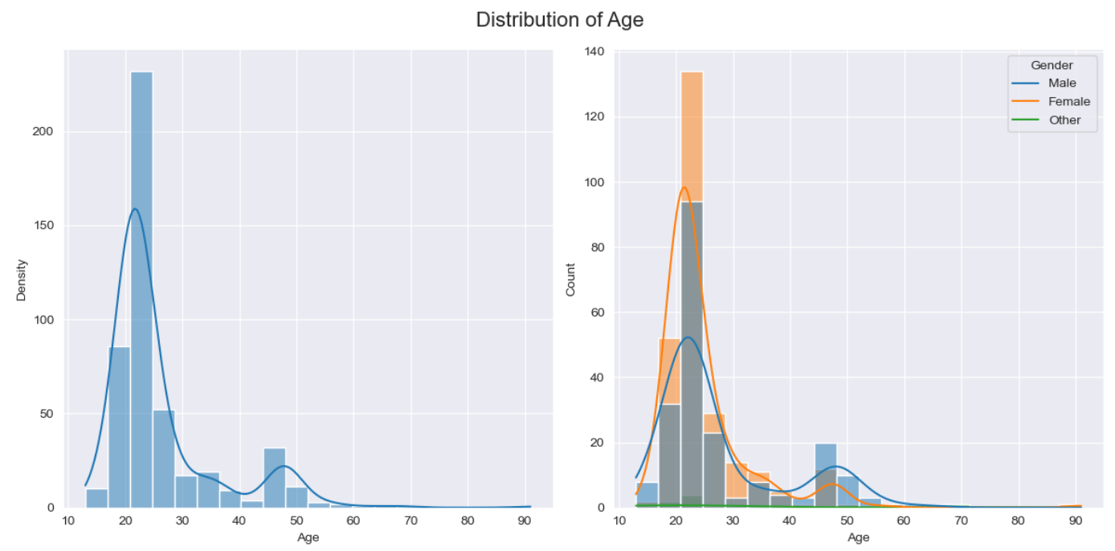
- Age Distribution: The age range is primarily concentrated around late teens to early twenties, with a peak around 20 years of age. This is evident in both the density plot (left) and the count plot (right).
- Gender Differences: The right plot (count plot with gender hue) shows that the female distribution (orange) is slightly higher than male distribution (blue) at the peak age of around 20, indicating a larger number of female respondents in that age group. Both genders show a rapid decline in counts as age increases past 30.
- Female Usage: Females appear more represented in the peak age group (around 20), which might suggest slightly higher engagement in social media platforms among young females compared to males in this dataset. The slight higher count of females at younger ages might indicate greater interaction or interest in social media-driven activities, validation, and comparison to others, which are part of the survey questions.
- Male Usage: Males show a broader distribution across ages with a slightly flatter curve than females. This might indicate more consistent but slightly lower engagement at younger ages, which could suggest different patterns of social media usage (perhaps more purpose-driven or less frequent checking).

Users among Genders
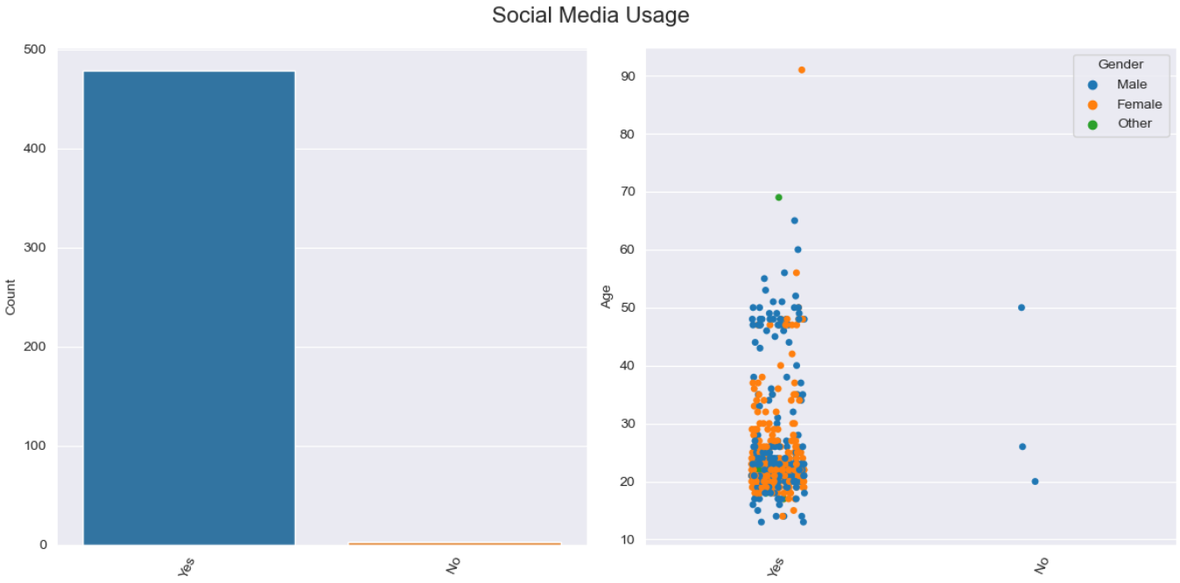
- Social Media Usage:
  - The majority of both males and females use social media (Yes).
  - There are only a few individuals who do not use social media (No).
- Age Distribution:
  - Social media usage spans across various ages, but most users are concentrated in younger age groups.
  - There are more data points for younger individuals compared to older individuals
- Gender Distribution:
  - Both males and females are represented in the Yes category, with a slight visual indication that more females might be present.
  - There are a few data points under the No category, with males seeming to be the majority.
Relationship Status

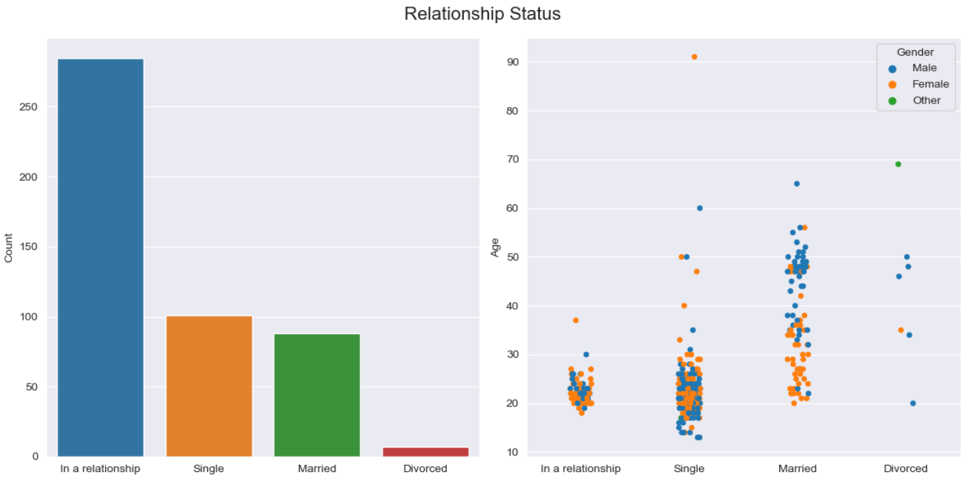
- In a Relationship:

  - The data points are clustered primarily among younger age groups (teens to early 30s).
  - Both males and females are similarly distributed, with females slightly more represented.
- Single:

  - The largest concentration of data points is in this category, indicating a large proportion of single individuals.
  - The age range is broad, from late teens to early 40s, with no significant gender imbalance.
- Married:

  - Most data points are clustered in the late 20s to 50s age range.
  - Both males and females are present, though the clustering of ages may vary slightly between genders.
- Divorced:

  - A smaller number of data points appear in this category, typically older than other statuses, mainly between 40 to 70 years.
  - There is no apparent gender imbalance, but the number of individuals is smaller, making it harder to draw definitive conclusions.

Occupations

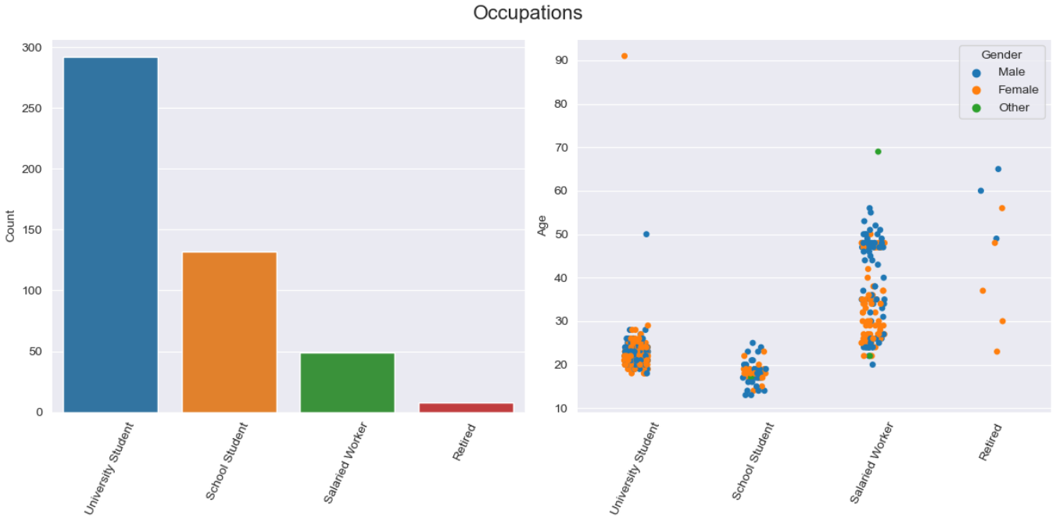

- University Student:

- Male: Blue dots are scattered around the age group of 20-30.
- Female: Orange dots are also scattered around the age group of 20-30.
- Both genders have similar representation in this occupation.
- School Student:

  - Male: Blue dots appear around the age group of 10-20.
  - Female: Orange dots are also clustered around the age group of 10-20.
  - Both genders are equally represented.
- Salaried Worker:

  - Male: Blue dots are spread across a broader age range, approximately 25-60 years.
  - Female: Orange dots are similarly distributed across the same age range.
  - Both genders have a wide representation in this occupation.
- Retired:

  - Male: Blue dots are scattered in the age range of approximately 60-90 years.
  - Female: Orange dots also appear in the same age range.
  - There are both male and female retirees, but there seems to be a higher concentration of females.
Observations:
- The occupations have a fairly equal distribution across genders.
- The Salaried Worker category shows a broad age range for both males and females.
- The University Student and School Student categories have a younger population, as expected, with balanced representation across genders.
- The Retired category, while less populated, shows both male and female representation.

Daily Usage in Hours

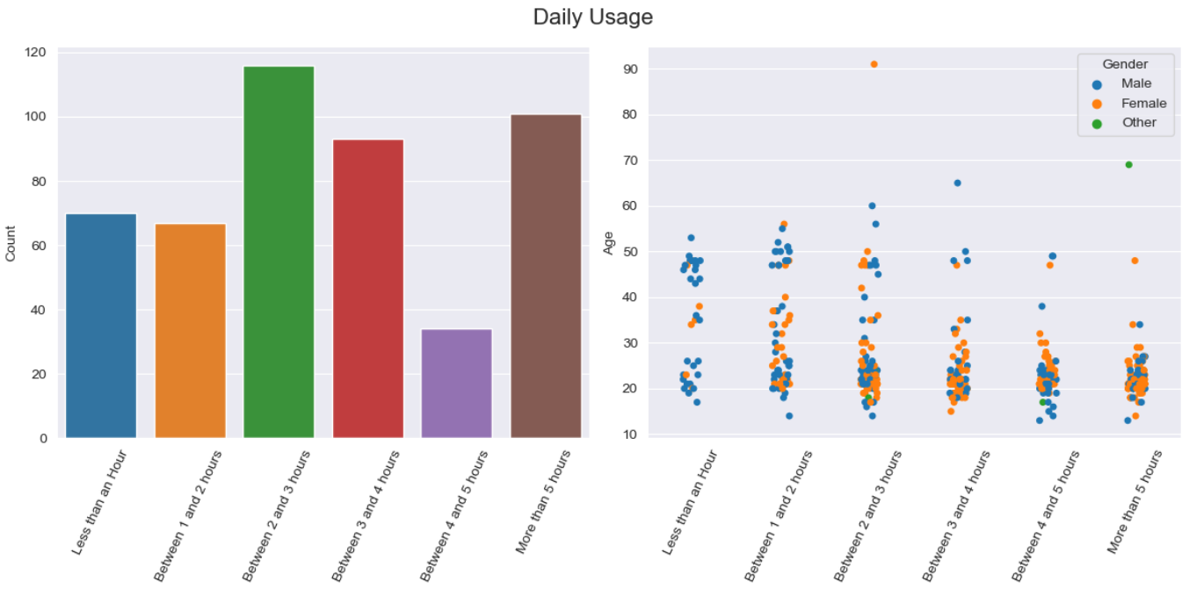

- Gender-based Patterns:

  - If there are more dots for one gender in a specific daily usage category, it suggests that this gender tends to spend more time on social media.
  - For example, if you see more female dots in "Between 1 and 2 hours" and more male dots in "More than 5 hours," it indicates that males tend to use social media for longer durations.
- Age-based Trends:

  - The vertical spread of dots can show how different age groups distribute their time on social media.
  - Younger age groups might be clustered in higher usage categories, while older age groups might be spread more evenly or clustered in lower usage categories.
- Overlapping Patterns:

  - If the dots for males and females overlap heavily in certain categories, it suggests similar usage patterns across genders.
  - On the other hand, if there's a clear separation between male and female dots across categories, it suggests a gender difference in daily social media usage.
Observations to Note:

- Cluster Locations: Look for where the majority of male and female dots are clustered. This tells you which daily usage category is most common for each gender.
- Age Group Distribution: Notice if certain age groups dominate specific daily usage categories for one gender over the other.

Data Preprocessing

Before preprocessing starts we remove all survey answer columns as these are not valid features and use ‘age’, ‘gender’, ‘relationship’, ‘occupation’, ‘social_media_use’ and ‘daily_usage’. The target will then be ‘risk’. After an 80% training data to 20% test data split, we single out the numerical feature of ‘age’ and divide the rest, which are categorical features into ordinal and nominal features. Through the preprocessor variable the age values are transformed into standard scaled values and one hot encoding and ordinal encoding is done on the nominal and ordinal features respectively. This is done to get valid predictions and for the machine learning models to train and predict properly.

Advantages and Disadvantages of Random Forest, XGBoost and Neural Network

Random Forest

Advantages:
- Robustness: Handles a large number of features and performs well even with unbalanced datasets.
- Versatility: Can be used for both classification and regression tasks.
- Feature Importance: Provides insights into feature importance, helping in feature selection.
Disadvantages:

- Complexity: Models can become complex with a large number of trees, making them slower to interpret and potentially slower to predict.
- Overfitting: While generally robust to overfitting, it can still overfit if not properly tuned, especially with a high number of trees and depth.
Performance:

- Accuracy: 56%
- Precision and recall: balance, but not very high for either class. The model shows moderate performance with a bit better precision for the higher class compared to the lower class

XGBoost
Advantages:
- Performance: Often provides better predictive performance due to its gradient boosting framework.
- Handling of Missing Values: Can handle missing values internally without the need for imputation.
- Flexibility: Offers a variety of hyperparameters for tuning, allowing for fine-grained control over the model.

Disadvantages:
- Complexity: Hyperparameter tuning can be complex and time-consuming.
- Interpretability: Less interpretable compared to simpler models like decision trees or linear models.
Performance:

- Accuracy: 71%
- Precision and recall: shows strong performance with high recall for the higher class and reasonable precision. However, it has lower recall for the lower class, indicating a trade-off

Neural Network
Advantages:
- Capability: Can model complex relationships and interactions between features due to its deep learning architecture.
- Flexibility: Can be adapted for various types of data and tasks with appropriate architecture adjustments.

Disadvantages:
- Data Requirements: Typically requires a large amount of data to perform well.
- Computationally Intensive: Training can be resource-intensive and time-consuming.
- Overfitting: High risk of overfitting if not properly regularized or if the model is too complex for the given data.

Performance:

- Accuracy: 66%
- Precision and recall: performs reasonably well, with balanced precision and recall for both classes. However, it is not as high-performing as XGBoost in terms of overall accuracy

Model Performance Comparison

Random Forest

precision recall f1-score support

higher 0.64 0.60 0.62 58
lower 0.45 0.49 0.47 39
accuracy 0.56 97
macro avg 0.54 0.55 0.54 97
weighted avg 0.56 0.56 0.56 97

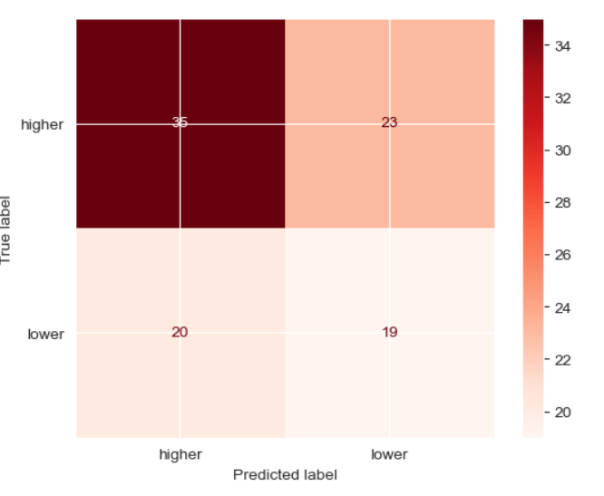

XGBoost

precision recall f1-score support

higher 0.70 0.89 0.78 57
lower 0.75 0.45 0.56 40
accuracy 0.71 97
macro avg 0.72 0.67 0.67 97
weighted avg 0.72 0.71 0.69 97

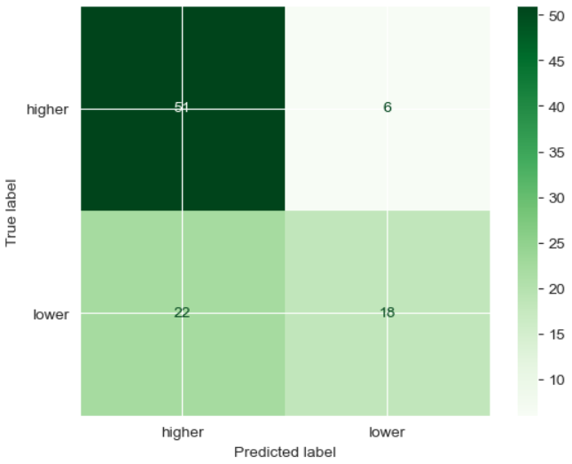

Neural Network

precision recall f1-score support

higher 0.69 0.75 0.72 57
lower 0.60 0.53 0.56 40
accuracy 0.66 97
macro avg 0.65 0.64 0.64 97
weighted avg 0.65 0.66 0.66 97

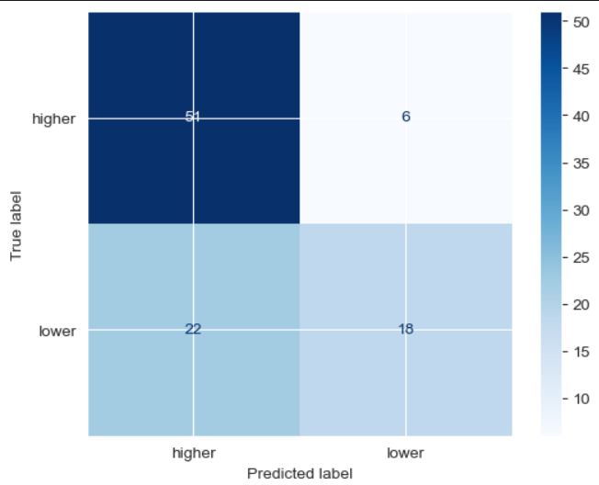

Best Model Choice

- XGBoost achieved the highest accuracy (71%) and the best F1-score for the higher class (0.78). It also performed better in recall for the higher class, which is crucial if that class is of higher importance.

- Neural Network had competitive results with a slightly lower accuracy (66%) but performed relatively well overall.
- Random Forest had the lowest accuracy (56%) and the lowest F1-scores for both classes.

Based on accuracy and performance metrics, XGBoost is the best model among the three. It has the highest accuracy and performs well in terms of recall for the higher class, which might be more critical depending on the specific application

Findings.

- XGBoost stands out as the best-performing model due to its superior accuracy and F1-scores, particularly for the higher class. This model’s ability to handle complex relationships and its effective use of boosting make it a strong choice for this classification task.
- Neural Network also provides good performance but is more computationally intensive and harder to interpret compared to XGBoost.
- Random Forest showed the least performance among the three models in this case, making it less suitable given the current results.

XGBoost is recommended as the best model for this classification problem based on the metrics provided.

6. CONCLUSIONS
The relationship between social media usage and emotional well-being is a multifaceted issue that requires comprehensive investigation. By integrating machine learning and natural language processing techniques, this research aims to develop predictive models that can accurately assess emotional well-being based on social media activity. The insights gained from this study will not only benefit the Maldivian community but also contribute to the broader field of mental health research, offering tools for early detection and intervention in various cultural contexts. This research holds the promise of improving mental health outcomes in the digital age, promoting a more supportive and healthy online environment for all users.

REFERENCES
- D’Cruz, L., Dubey, V., & Thakur, P. (2023). Depression Prediction from Combined Reddit and Twitter Data Using Machine Learning.
- Han, N., Li, S., Huang, F., Wen, Y., Wang, X., Liu, X., & Zhu, T. (2023). Sensing Psychological Well-being Using Social Media Language: Prediction Model Development Study
- Abdurrahim, & Fudholi, D. H. (2024). Mental health prediction model on social media data using CNN
- Zarated, D., Balla, M., Prokofieva, M., Kostakos, V., & Stavropoulos, V. (2023). Identifying self-disclosed anxiety on Twitter: A natural language processing approach
- Louati, A., Louati, H., Albanyan, A., Lahyani, R., Kariri, E., & Alabduljabbar, A. (2024). Harnessing machine learning to unveil emotional responses to hateful content on social media.
- Inamdar, S., Chapekar, R., Gite, S., & Pradhan, B. (2023). Machine learning driven mental stress detection on Reddit posts using natural language processing.
- Safa, R., Edalatpanah, S. A., & Sorourkhah, A. (2023). Predicting mental health using social media: A roadmap for future development.
- Ismail, L., Shahin, N., Materwala, H., Hennebelle, A., & Frermann, L. (2023). ML-NLPEmot: Machine learning-natural language processing event-based emotion detection proactive framework addressing mental health.
- Swain, V. D., Ye, J., Ramesh, S. K., Mondal, A., Abowd, G. D., & De Choudhury, M. (2023). Leveraging social media to predict COVID-19–induced disruptions to mental well-being among university students: Modeling study.
- Merayo, N., Vegas, J., Llamas, C., & Fernández, P. (2023). Social network sentiment analysis using hybrid deep learning models.
- Malhotra, A., & Jindal, R. (2023). XAI transformer-based approach for interpreting depressed and suicidal user behavior on online social networks.

Source code as an appendix

import numpy as np
import pandas as pd

import matplotlib.pyplot as plt
import seaborn as sns

# Set seaborn plot stylings
sns.set_style("darkgrid")
pd.set_option('display.max_columns', None)s

import warnings
warnings.filterwarnings("ignore")

df = pd.read_csv("data/smmh.csv", on_bad_lines='skip')

# Rename column names for readability and easier indexing
col_names_dict = {
'Timestamp': 'timestamp',
'1. What is your age?': 'age',
'2. Gender': 'gender',
'3. Relationship Status': 'relationship',
'4. Occupation Status': 'occupation',
'5. What type of organizations are you affiliated with?': 'affiliate_organization',
'6. Do you use social media?': 'social_media_use',
'7. What social media platforms do you commonly use?': 'platforms',
'8. What is the average time you spend on social media every day?': 'daily_usage',
'9. How often do you find yourself using Social media without a specific purpose?': 'without_purpose',
'10. How often do you get distracted by Social media when you are busy doing something?': 'distracted',
"11. Do you feel restless if you haven't used Social media in a while?": 'restless',
'12. On a scale of 1 to 5, how easily distracted are you?' : 'distracted_ease',
'13. On a scale of 1 to 5, how much are you bothered by worries?' : 'worries',
'14. Do you find it difficult to concentrate on things?' : 'concentration',
'15. On a scale of 1-5, how often do you compare yourself to other successful people through the use of social media?' : 'compare_to_others',
'16. Following the previous question, how do you feel about these comparisons, generally speaking?' : 'compare_feelings',
'17. How often do you look to seek validation from features of social media?' : 'validation',
'18. How often do you feel depressed or down?' : 'depressed',
'19. On a scale of 1 to 5, how frequently does your interest in daily activities fluctuate?' : 'daily_activity_flux',
'20. On a scale of 1 to 5, how often do you face issues regarding sleep?' : 'sleeping_issues'
}

df = df.rename(columns=col_names_dict).drop(columns=['timestamp', 'affiliate_organization', 'platforms'])

# General data info
display(df.info())

# Convert float age values to int values

display(df['age'].dtype) # float64

df['age'] = df['age'].astype(int)

display(df['age'].dtype) # int32

# Clean gender column
display(df['gender'].value_counts())
print("\n")

df['gender'] = df['gender'].apply(lambda x: x if x in ["Male","Female"] else "Other")

display(df['gender'].value_counts())

# Checking for null values
print("Null Data Values:\n")
display(df.isnull().sum())

# Histogram Plot for age column
fig, ax = plt.subplots(1,2, figsize=(12,6))
sns.histplot(data=df, x="age", kde=True, bins=20, ax=ax[0])
sns.histplot(data=df, x="age", kde=True, bins=20, hue="gender", ax=ax[1], legend=False)
# ax[1].legend(title="Gender")
fig.suptitle("Distribution of Age", fontsize=16)
ax[0].set_xlabel("Age")
ax[0].set_ylabel("Density")
ax[1].set_xlabel("Age")
plt.legend(title='Gender', loc='upper right', labels=['Other', 'Female', 'Male'], reverse='True')
plt.tight_layout()
# plt.show()

# Bar Plot and Dot Plot for social_media_use column
fig, ax = plt.subplots(1,2, figsize=(12,6))
sns.barplot(data=df, x=df['social_media_use'].unique(), y=df['social_media_use'].value_counts(), ax=ax[0])
ax[1] = sns.stripplot(data=df, x=df['social_media_use'], y=df['age'], hue="gender")
ax[1].legend(title="Gender")
fig.suptitle("Social Media Usage", fontsize=16)
ax[0].set_xlabel("")
ax[0].set_ylabel("Count")
ax[1].set_xlabel("")
ax[1].set_ylabel("Age")
ax[0].tick_params(axis='x', rotation=65)
ax[1].tick_params(axis='x', rotation=65)
plt.tight_layout()
# display(df['social_media_use'].unique())
# display(df['social_media_use'].value_counts())

# Bar Plot and Dot Plot for relationship column
fig, ax = plt.subplots(1,2, figsize=(12,6))
sns.barplot(data=df, x=df['relationship'].unique(), y=df['relationship'].value_counts(), ax=ax[0])
ax[1] = sns.stripplot(data=df, x=df['relationship'], y=df['age'], hue="gender")
ax[1].legend(title="Gender")
fig.suptitle("Relationship Status", fontsize=16)
ax[0].set_xlabel("")
ax[0].set_ylabel("Count")
ax[1].set_xlabel("")
ax[1].set_ylabel("Age")
plt.tight_layout()

# Bar Plot and Dot Plot for occupation column
fig, ax = plt.subplots(1,2, figsize=(12,6))
sns.barplot(data=df, x=df['occupation'].unique(), y=df['occupation'].value_counts(), ax=ax[0])
ax[1] = sns.stripplot(data=df, x=df['occupation'], y=df['age'], hue="gender")
ax[1].legend(title="Gender")
fig.suptitle("Occupations", fontsize=16)
ax[0].set_xlabel("")
ax[0].set_ylabel("Count")
ax[1].set_xlabel("")
ax[1].set_ylabel("Age")
ax[0].tick_params(axis='x', rotation=65)
ax[1].tick_params(axis='x', rotation=65)
plt.tight_layout()

# Bar Plot and Dot Plot for daily_usage column
order_list = ['Less than an Hour', 'Between 1 and 2 hours', 'Between 2 and 3 hours',
'Between 3 and 4 hours', 'Between 4 and 5 hours', 'More than 5 hours']

fig, ax = plt.subplots(1,2, figsize=(12,6))
sns.barplot(data=df, x=df['daily_usage'].unique(), y=df['daily_usage'].value_counts(), ax=ax[0], order=order_list)
ax[1] = sns.stripplot(data=df, x=df['daily_usage'], y=df['age'], hue="gender", order=order_list)
ax[1].legend(title="Gender")
fig.suptitle("Daily Usage", fontsize=16)
ax[0].set_xlabel("")
ax[0].set_ylabel("Count")
ax[1].set_xlabel("")
ax[1].set_ylabel("Age")
ax[0].tick_params(axis='x', rotation=65)
ax[1].tick_params(axis='x', rotation=65)
plt.tight_layout()

# Adding a column for calculating impact on mental health
df['impact_score'] = df.iloc[:, 6:18].sum(axis=1)
df.head()

# Histogram Plot for new impact_score column
plt.figure(figsize=(14,6))
ax = sns.histplot(data=df, x="impact_score", bins=48)
ax.set_title("Negative Impact Scoring", fontsize=16)
ax.set(xlabel='Impact Score')
# plt.show()
plt.tight_layout()

# Adding a column for the risk based on impact_score column
df["risk"] = "lower"
df.loc[df[df['impact_score'] >= 37].index, "risk"] = "higher"
df['risk'] = df['risk'].astype("category")

df.head()

# Histogram Plot for new risk column
plt.figure(figsize=(14,6))
ax = sns.histplot(data=df, x='impact_score', bins=48, hue='risk')
ax.set_title("Risk Calculation", fontsize=14)
ax.set(xlabel='Risk')
# plt.show()
plt.tight_layout()

from sklearn.model_selection import train_test_split, GridSearchCV, cross_val_score
from sklearn.preprocessing import OneHotEncoder, OrdinalEncoder, StandardScaler, LabelEncoder
from sklearn.compose import ColumnTransformer
from sklearn.pipeline import Pipeline
from sklearn.ensemble import RandomForestClassifier
from xgboost import XGBClassifier
from sklearn.metrics import classification_report, ConfusionMatrixDisplay
from tensorflow.keras.models import Sequential
from tensorflow.keras.layers import Dense, Dropout
from tensorflow.keras.utils import to_categorical

# Define features and target
# X = df.drop(df.iloc[:, 6:18], axis=1).drop(columns=['risk']) # Features
# y = (df['risk'] == 'higher').astype(int) # Target, 1 = higher, 0 = lower
X = df.iloc[:, 0:6]
y = df['risk'] # Target, 1 = higher, 0 = lower

display(X.head())
display(y.head())

# display(X['age'].value_counts())

# Splitting data into a training set and a test set
X_train, X_test, y_train, y_test = train_test_split(X, y, test_size=0.2, random_state=5)

# display(X_train.head())
# display(y_train.head())

# display(X_test.head())
# display(y_test.head())

# Data Preprocessing
numeric_feat = ['age']
nominal_feat = ['gender', 'relationship', 'occupation', 'social_media_use']
ordinal_feat = ['daily_usage']

preprocessor = ColumnTransformer(transformers=[
('num', StandardScaler(), numeric_feat),
('nominal', OneHotEncoder(), nominal_feat),
('ordinal', OrdinalEncoder(), ordinal_feat)]
)

# Random Forest Classifier with GridSearchCV
rf_pipeline = Pipeline(steps=[('preprocessor', preprocessor),
('classifier', RandomForestClassifier(random_state=42))])

param_grid = {
'classifier__n_estimators': [100, 200, 300],
'classifier__max_depth': [None, 10, 20, 30],
'classifier__min_samples_split': [2, 5, 10],
'classifier__min_samples_leaf': [1, 2, 4]
}

grid_search_rf = GridSearchCV(rf_pipeline, param_grid, cv=5, n_jobs=-1)
grid_search_rf.fit(X_train, y_train)

print("Best Parameters for Random Forest:", grid_search_rf.best_params_)

y_pred_rf = grid_search_rf.predict(X_test)

print("Random Forest Classifier Report:")
print(classification_report(y_test, y_pred_rf))
ConfusionMatrixDisplay.from_predictions(y_test, y_pred_rf, cmap=plt.cm.Reds)

# XGBoost Classifier with GridSearchCV
label_encoder = LabelEncoder()
y_encoded = label_encoder.fit_transform(y)

X_train, X_test, y_train, y_test = train_test_split(X, y_encoded, test_size=0.2, random_state=42)

xgb_pipeline = Pipeline(steps=[('preprocessor', preprocessor),
('classifier', XGBClassifier(random_state=42))])

param_grid = {
'classifier__n_estimators': [100, 200, 300],
'classifier__max_depth': [3, 5, 7, 9],
'classifier__learning_rate': [0.01, 0.1, 0.2]
}

grid_search_xgb = GridSearchCV(xgb_pipeline, param_grid, cv=5, n_jobs=-1)
grid_search_xgb.fit(X_train, y_train)

print("Best Parameters for XGBoost:", grid_search_xgb.best_params_)

y_pred_xgb = grid_search_xgb.predict(X_test)

y_test_decoded = label_encoder.inverse_transform(y_test)
y_pred_xgb_decoded = label_encoder.inverse_transform(y_pred_xgb)

print("XGBoost Classifier Report:")
print(classification_report(y_test_decoded, y_pred_xgb_decoded))
ConfusionMatrixDisplay.from_predictions(y_test_decoded, y_pred_xgb_decoded, cmap=plt.cm.Greens)

# Neural Network
X = df.iloc[:, 0:6]
y = df['risk']

label_encoder = LabelEncoder()
y_encoded = label_encoder.fit_transform(y)

y_onehot = to_categorical(y_encoded)

X_train, X_test, y_train, y_test = train_test_split(X, y_onehot, test_size=0.2, random_state=42)

numeric_feat = ['age']
nominal_feat = ['gender', 'relationship', 'occupation', 'social_media_use']
ordinal_feat = ['daily_usage']

preprocessor = ColumnTransformer(transformers=[
('num', StandardScaler(), numeric_feat),
('nominal', OneHotEncoder(), nominal_feat),
('ordinal', OrdinalEncoder(), ordinal_feat)]
)

X_train = preprocessor.fit_transform(X_train)
X_test = preprocessor.transform(X_test)

# Build the neural network
model = Sequential()
model.add(Dense(128, input_dim=X_train.shape[1], activation='relu'))
model.add(Dropout(0.5))
model.add(Dense(64, activation='relu'))
model.add(Dropout(0.5))
model.add(Dense(y_onehot.shape[1], activation='softmax'))

model.compile(optimizer='adam', loss='categorical_crossentropy', metrics=['accuracy'])

model.fit(X_train, y_train, epochs=50, batch_size=32, validation_split=0.1)

loss, accuracy = model.evaluate(X_test, y_test)
print(f'Accuracy: {accuracy:.2f}')

y_pred = model.predict(X_test)
y_pred_classes = np.argmax(y_pred, axis=1)
y_test_classes = np.argmax(y_test, axis=1)

y_pred_labels = label_encoder.inverse_transform(y_pred_classes)
y_test_labels = label_encoder.inverse_transform(y_test_classes)

print("Neural Network Classifier Report:")
print(classification_report(y_test_labels, y_pred_labels))
ConfusionMatrixDisplay.from_predictions(y_test_decoded, y_pred_xgb_decoded, cmap=plt.cm.Blues)

